**Display options with Tableau**

Tableau display dashboards and reports sizes irrespective of the OS like Windows and MAC with the display options it provides within the Tableau desktop dashboard layouts.

The details are mentioned below:

Tableau desktop comes with two different settings:

1. **Default**
2. **Phone**
3. Default again comes with three different options:
4. **Automatic:**

With this setting the dashboard will adjust automatically with the screen size irrespective of any machine type.

1. **Fixed Size:**

With this setting the dashboard will adjust to the screen size you choose and will be fixed unless one changes the option. One can also choose the custom option under the in Fixed Size setting option.

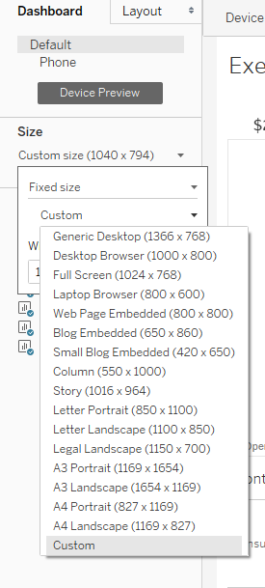

1. **Range**:

With this setting there are two ranges are provided with minimum and maximum values.

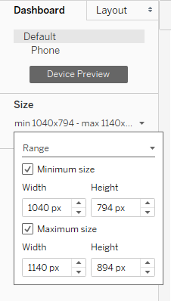

1. **Phone**

With this option you can choose on which mobile device one want to show the dashboard, for example, one want to view the report on Iphone 7 Plus, so it will adjust to the device dimension.

